
A12
Sreenidhi Institute of Science and Technology
(An Autonomous Institution)
Code No: 3H314
B. TECH. II-Year I-Semester Examinations, December 2015 (Supplementary)
ENGINEERING MATHEMATICS-III (COMMON TO ALL EXCEPT - BT)

Time: 3 Hours Max. Marks: 70

Note: No additional answer sheets will be provided.

Part - A
Max.Marks:20

Answer all QUESTIONS. EACH QUESTION CARRIES 2 MARKS.
- Evaluate , using Gamma function
- Show that the function is harmonic
- Define isolated singularity with an example
- Derive Newton’s iterative formula to find
- Find if
- Explain Taylor series method for solving 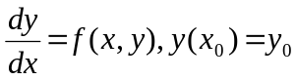
- Express in terms of Legendre’s polynomials
- Explain Bisection method
- Prove that
- State Cauchy’s integral theorem

Part – B
Max.Marks:50

ANSWER ANY FIVE QUESTIONS. EACH QUESTION CARRIES 10 MARKS.
- (a) Prove that 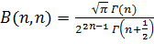
(b) Prove that 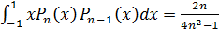

- (a) Evaluate along
(b) Find the analytic function whose real part is 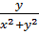

- (a) Find the Laurent’s expansion of 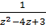 for
(b) Evaluate 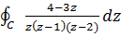 where C is the circle using residue theorem

- (a) Compute a real root of 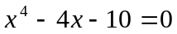correct to 3 decimal places by Regula Falsi method
(b) Evaluate 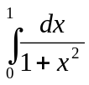 using Simpson’s 3/8th rule taking h=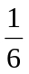
- (a) Calculate the approximate value of 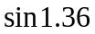 using Newton Backward interpolation formula from the following table

x | 0.5 | 0.7 | 0.9 | 1.1 | 1.3 | 1.5
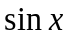 | 0.4794 | 0.6442 | 0.7833 | 0.8912 | 0.9636 | 0.9975

(b) Estimate the value of when 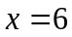 by Lagrange’s interpolation formula from the
following data
 | 0 | 1 | 2 | 8
 | 5 | 9 | 15 | 86

- (a) Find 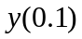, if 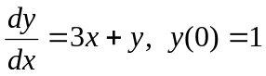 by Runge Kutta method
(b) Solve 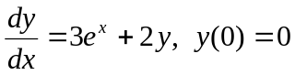 by Taylor series method upto 4 terms and find 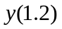
- (a) Show that 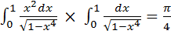

(b) Evaluate 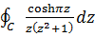 , where by Cauchy’s integral formula

- (a) Find a real root of 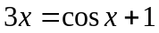 by Newton Raphson method
(b) Determine for the following data by Newton divided difference formula

 | 1 | 2 | 5 | 6 | 11
 | 22 | 15 | 6 | 7 | 42

-- 00 -- 00 --

